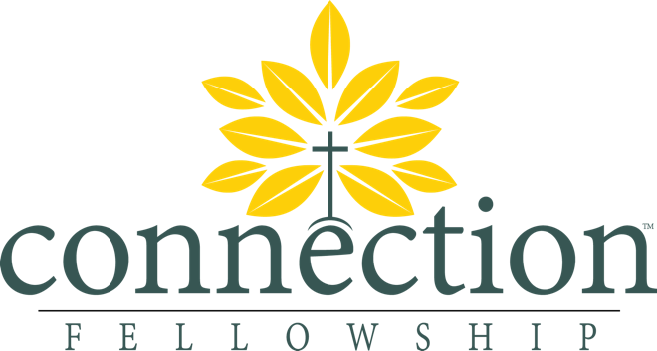

Journey Groups

The Mission of our Journey Groups
Journey groups exist to glorify God through Gospel-centered, consistent fellowship: includes prayer, doing life together, service, accountability, transparency, mission, growing in biblical knowledge and application.

Our Method
- Shepherd – Give spiritual guidance, support, and accountability to every member of your Journey Group through the Word of God and prayer.
- Serve – Be the “first responders” to the physical needs of each member of your Journey Group.
- Saturate - Intentionally get to know your spheres of influence (i.e. neighbors, co-workers, biological family, church family) as you meet their physical needs and minster to them with the Word of God. Gospel Sharing (the gospel content) and Gospel Living (gospel empowered hearts & deeds) both locally (where God has put you) and abroad (where God may lead you) is essential to expanding the influence of your Journey Group and accomplishing our mission together.
- Splant – Intentionally pursue training new leaders and starting new groups from already existing Journey Groups. Have a willingness to embrace change for the health of the church and the hope of our community.

Our Mindset as we Minister
Connection Fellowship is a missional church; that is to say, we believe we have been placed by God in our current context for the benefit of the community/culture/people around us. We strive to walk beside our community, sharing the greatness of the Gospel with each other in a way that is loving, compassionate, edifying, and effective. As such is the case, we present you with these guidelines for Journey Group interaction and discussion, not only in homes, but in your respective neighborhoods, workplaces, and families.
- We resolve to learn our culture and speak the language of our culture, learning what is good and can be enjoyed/celebrated, learning what is anti-gospel and is to be rejected, and learning what can be renewed or adapted for God-glorifying ends.
- We resolve to avoid speaking Christian-ese, or in-house jargon, or super-spiritual, overly pious language. We also resolve to avoid technical theological terms unless we explain them.
- We resolve to avoid “we-them” language, which belittles people of different political, spiritual, and social positions, or is disrespectful of people whom we disagree. We resolve, not only to tolerate, but to love those who oppose Christ, engaging them with the truth of the Gospel for their good and not for personal glory.
- We resolve to speak as if non-Christians were always present.
- We resolve to be known for our love for one another. We will maintain patience, mend broken relationships, and preach the Gospel to one another.
- We resolve to engage people humbly, admitting our weaknesses and failures, while demonstrating the joyful difference the gospel makes.
- We resolve to do all the above, not out of piety, pretense, or pride, but out of the fruit of a heart that has been rescued from damnation and changed by the gracious Gospel of Christ.

Mercy Meals
Mercy Meals are one way to serve your Journey Group and the larger body at Connection Fellowship through signing up to purchase or provide a meal for someone who is facing a major transition or trial of life.

When hearing of a serious illness/hospitalization, birth/adoption or death of someone attending Connection Fellowship please take the following steps:

(1st) Check and see if the person has any needs and if they would like assistance through meals.
(2nd) Notify the person’s Journey Group leader of the need if applicable.
(3rd) Notify Sandy Cochran who is the head of our Mercy Meals. (864) 643-9443

***Please do these above steps before working out the details of food preparations with the person in need.

